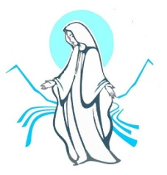
Our Lady of the Valleys Parish

Parish Priest |  | Father Maleko Api-Tufuga
Churches |  | Our Lady of Grace Church, 5 Palmer Crescent, Heretaunga (HTG)  St Francis Xavier Church, 152 Stokes Valley Road. Stokes Valley (SV)
Sunday Eucharist |  | Sat 5:30 pm Vigil (SV) |  | 8:30 am (SV) and 10:30 am (HTG)
Weekday Eucharist |  | Tuesday / Thursday  Wednesday/Saturday  Friday |  | 9:00 am (Stokes Valley)  9:00 am (Heretaunga)  9:30 am (Heretaunga)
Adoration of Blessed Sacrament |  | Friday |  | 10:00 am to 6:00 pm (Heretaunga)
Reconciliation |  | Every Saturday at 9.30 am (Heretaunga)
Presbytery and  Parish Office |  | 5 Palmer Crescent  Heretaunga |  | Tel | (04) 972 4282
Parish Administrator |  | Monday – Friday |  | 9:00 am – 1:00 pm
Website |  | www.olov.org.nz | E-mail |  | office@olov.org.nz pp@olov.org.nz
St Brendan’s School |  | 56 Palmer Cres | Tel |  | (04) 939 1909
Newsletter |  | 23 June, Term 2 2026 Newsletter
17th Sunday in Ordinary Time |  | READINGS  YEAR A |  |  |  | 26th July 2026
26th July | 1st Reading  2nd Reading  Gospel | 1Kings 3: 5,7-12  Romans 8: 28-30  Matthew 13: 44-52 |  |  |  | 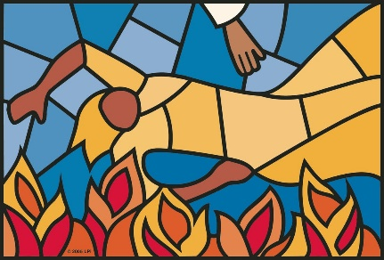
2nd August | 1st Reading  2nd Reading  Gospel | Isaiah 55: 1-3  Romans 8: 35, 37-39  Matthew 14: 13-21
UPCOMING EVENT
Wed 29th July  Sat 1st Aug | 10.00 am  02.00 pm | Coffee morning at the Royal Wellington Golf Club  Circle of Friendship at the Pettit Centre
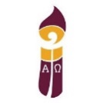
EVENTS IN THE ARCHDIOCESE
What is happening around our Diocese? Stay up to date with Archdiocesan events - https://www.wn.catholic.org.nz/events/

PLEASE NOTE THERE WILL BE NO WEEKDAY MASSES AT BOTH SFX AND OLOG FROM THE 28TH TO THE 31ST OF JULY AS THE PRIESTS ARE AT A LITURGY SEMINAR.



6TH WORLD DAY FOR GRANDPARENTS AND THE ELDERLY CELEBRATED ON 26TH JULY, 2026.

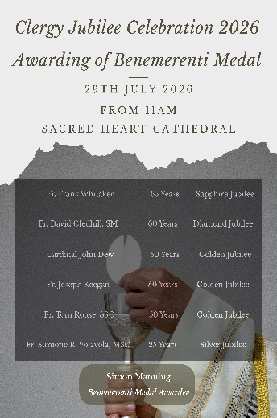
CLERGY JUBILEE CELEBRATION 2026
Wednesday 29th July – Sacred Heart Cathedral – 11:00AM
Come and celebrate this special Jubilee Mass with the priests of the Archdiocese as we acknowledge:
Fr Frank Whitaker 65 years
Fr David Gledhill SM 60 years
Cardinal John Dew 50 years
Fr Joe Keegan 50 years
Fr Tom Rouse SSC 50 years
Fr Simi Volavola MSC 25 years


THROUGH THE LENS OF THE GOSPEL
World Day of Grandparents and the Elderly
Even as consensus emerged on many fronts, inherent divergences also remained in the listening process. While many called for greater inclusion of women in decision-making roles, and for their ordination to the diaconate or priesthood, others voiced discomfort or offered alternative solutions: ‘Many voiced a strong opinion on the need for women in ministry while others, a small but vocal minority, insisted that the best way forward was a male diaconate and foreign priests, however the differences in culture was cited as a major obstacle.’

Views ranged from acceptance of the current exclusion, while requesting clear explanations: ‘Some expressed acceptance of the exclusion of women to ordination while asking that people be told why this is so,’ to calls for greater inclusion: ‘On the role of women, strong support for expanded participation (including diaconate) coexisted with some expressing a view that current roles were sufficient.’

Some saw the persistence of the theme as a step forward, while others saw its continued resurfacing as inadequate or patronising. Divergences were often tied to theological interpretations, cultural differences, and the pace of change. Others linked the discussion to trust and transparency, noting ‘lack of trust was also partly present in relation to women and the absence of reference to ordination to the diaconate.’

From Baptised and Sent #24


ARCHDIOCESAN COMMISSION FOR ECOLOGY, JUSTICE AND PEACE
‘If you truly want to encounter the Risen Lord, then listen to his word, which is the Gospel of salvation. Reflect on your way of living, and seek justice in order to build a more humane world.’
Pope Leo XIV

CIRCLE OF FRIENDSHIP
Our next Gathering is on Saturday, 1st August at the Pettit Centre at 2pm. Our speakers are Janice and Pat Hoult who will speak to us about their recent trip to China.
Please feel free to bring along a friend who may be interested in joining us. As usual, donations are always gratefully accepted. Don't forget our book swap. We will end the afternoon with our usual chat and cuppa.
ALSO - don't forget the Reel Movie Night at St Mary's Church from 6.30pm at the Church on 8 August (2nd Saturday of every month). Tea, coffee and biscuits available. All very welcome.

NOMINATION OF NEW PARISH COUNCILLORS AT 2026 AGM

With an eye of the upcoming Annual General Meeting on 30th August 2026, two current Parish Councillors’ term of appointment have come to an end. Currently Parish Councillors stand for a two-year term with the right of renewal for two more terms.
We are therefore opening nominations for new Parish Councillors from 18th July 2026. From this weekend nomination forms are available in the foyer of both churches. These should be filled in and returned back to the Parish Office by Friday 14th August. This time frame allows time for the nominated candidates’ names to be advised to the Parish before the Annual General Meeting.
Please take the time to prayerfully discern who you think might be a suitable person to serve our Parish on the Parish Council. If you would like more details on the role of Parish Councillors and the function of the Parish Council please feel free to speak to one of the existing Parish Councillors or Father Maleko.
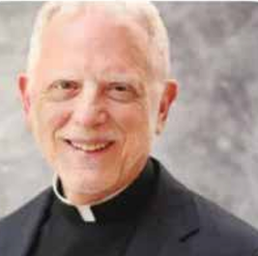
LITURGY WORKSHOP OPPORTUNITY

US liturgist and parish priest, Fr Paul Turner, will lead a liturgy seminar on Saturday, 1 August 2026 (9.30am - 2.00pm), in Connolly Hall, Hill Street, Wellington. Clergy, liturgy teams, school staff, and all involved in Eucharistic preparation are encouraged to join us for Ars Celebrandi: The Art of Celebrating Mass. Inspired by Pope Francis’, Desiderio Desideravi, the day will explore how we can celebrate liturgy with reverence and fidelity. Fr Turner will offer practical guidance to deepen understanding of the Eucharist and strengthen parish and school celebrations.

HOLY HOUR
For vocations to the priesthood and religious life. JOIN US for an hour of adoration, reflection and prayer that the Lord may send more workers to the harvest! 7.30 - 8.30pm at Sacred Heart Cathedral, Hill Street, Thorndon on Tuesday, 28th July and every 4th Tuesday of the month.

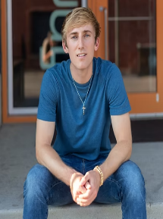
UNDERSTANDING YOUNG PEOPLE TODAY:
Teens today face constant pressure, comparison, and shifting values. Yet behind it all is a generation longing for real love, lasting truth, and a deeper purpose. Join Braden Johnson, a young Catholic speaker and content creator from the USA, for an evening exploring the challenges young people face today - and how we can help them rise above them. Ideal for clergy, youth ministry leaders, parents, grandparents, teachers, and PPC members. Hope is real, hearts can be reached, and you don’t have to do it alone. Wednesday 29 July, at Connolly Hall, 10 Guildford Terrace, Thorndon, Wellington from 7.00 – 9.00pm (hospitality from 6.30pm) or online (Zoom linkhere).

“SOLEMNITY OF THE ASSUMPTION OF THE BLESSED VIRGIN MARY”
The Divine Retreat Centre NZ, Wellington Unit, warmly invites you to come and celebrate the beautiful Marian feast as we honour Our Blessed Mother. On the Solemnity of the Assumption of the Blessed Virgin Mary join us for an afternoon of prayer, worship, and grace featuring a Reflections, a Charismatic Healing Mass, and Eucharistic Adoration.
Saturday, 15 August 2026 from 2:30 PM – 6:00 PM at Sacred Heart Church Petone. Presider: Fr. Kevin Connors

Marriage Seminar:
To be held on Wednesday, 19 August, hospitality from 6.30pm, session will start 7.00pm. Venue is at Connolly Hall, 10 Guildford Terrace, Thorndon, Wellington. 'Happily Married in a Tech Obsessed World'. Explore how we can be present and nurture a healthy marriage in a world where so much demands our attention. Queries to: marriage@cadw.nz

PLEASE REMEMBER IN PRAYER all who are sick and unwell, and those who are lonely. We pray also for those who have died recently especially David Carter, John Burt and Mary Brito, and for those whose anniversaries occur around this time.

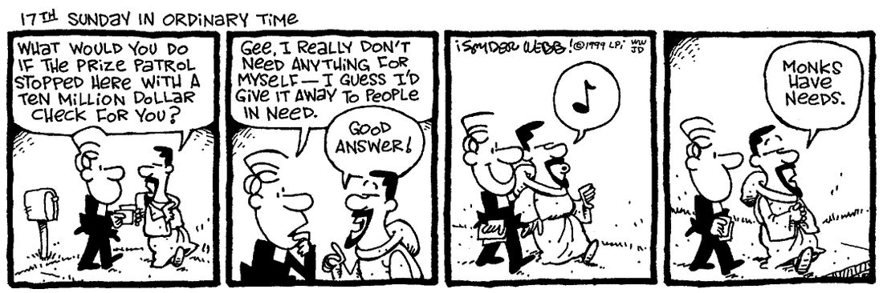

FOR THE YOUNG ONES

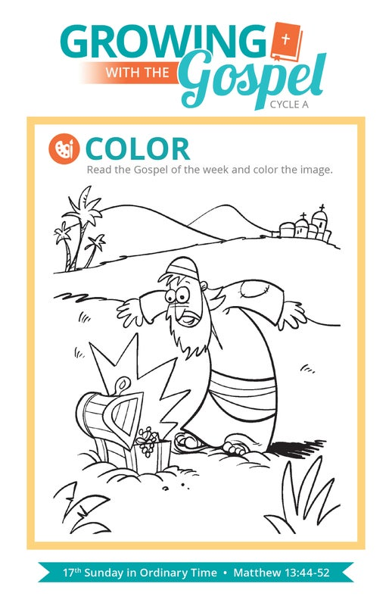

PUZZLE FOR YOU

